Contents

1 Administrator Module 2

1.1 Create New Account/Repository 2

1.2 Create New Project 3

1.3 Add Team Member to the Project 5

1.4 Administrator Module 8

1.4.1 History 8

1.4.2 Code 8

1.4.3 Assigning Work Item 8

1.4.4 Notification 10

2 User Module 12

2.1 Connect to Team Foundation Server 12

2.2 Clone Repository 15

2.3 Create New Project 17

2.4 Open Existing Project 18

2.5 Commit Changes 19

2.6 Create Local Branch 21

2.7 Merge Local Branch 23

2.8 Pull Changes from Team Members 24

3 Miscellaneous 25

3.1 Updating Same file 25

# Administrator Module

## Create New Account/Repository

* Login into Microsoft account

<https://visualstudio.com>

* After login to this site, click “visual studio team service” -> “Git”->”Free Account” (or)“Create Account”, following screen popup. Enter the account name, select “Git” to manage code and click “Continue”

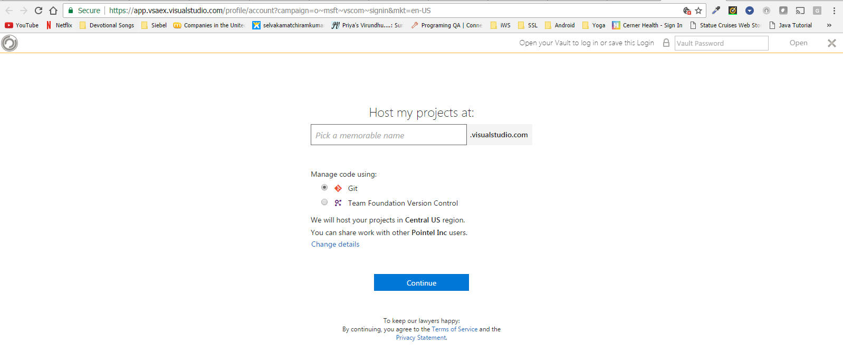

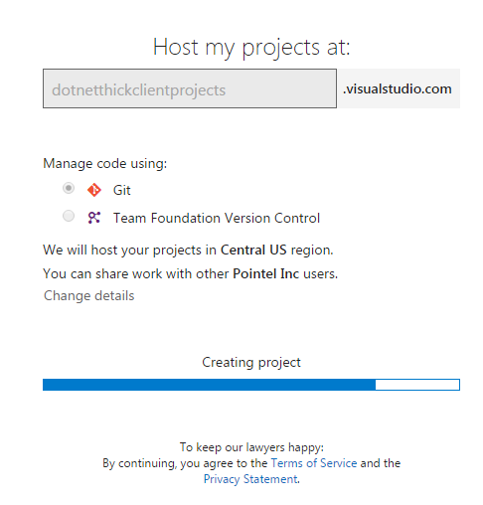

* Once account created, a new project will be added “MyFirstProject” will be added by default.

Note: We can avoid this default project creation by clicking “Change details” link, which will prompt to give appropriate details to create project (refer section 1.2).

## Create New Project

* Click “New team project” from the account as given below

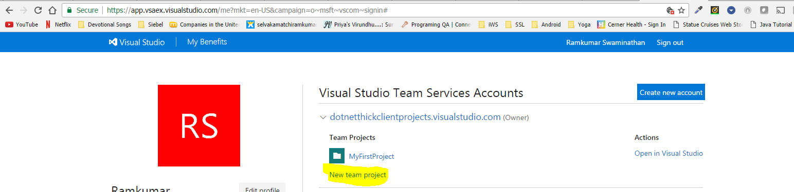

* Enter Project Name and other details. Since we are following CMMI methodology chose “CMMI” for work item process.

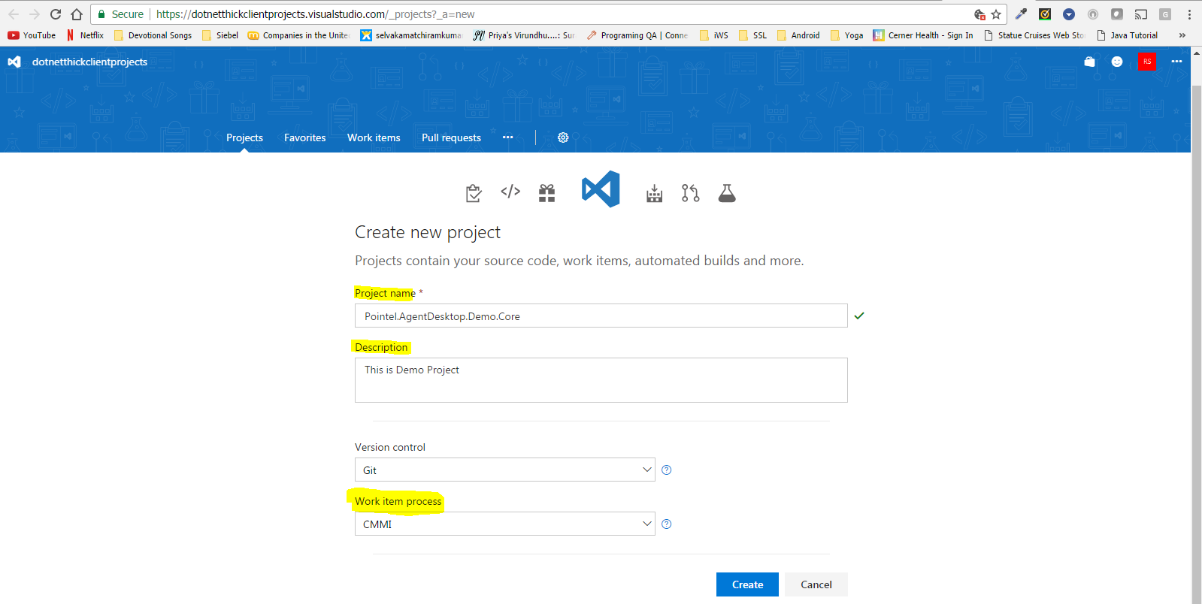

* Copy the URL and give it to Team Member.

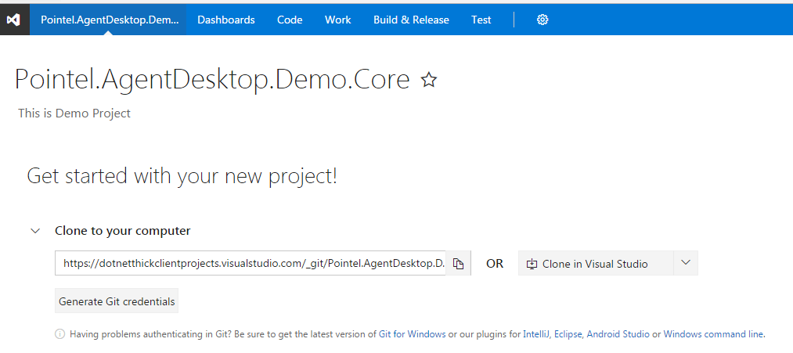

## Add Team Member to the Project

* Below screen shot shows how to add team member to the project. Click “+” in the Member section.

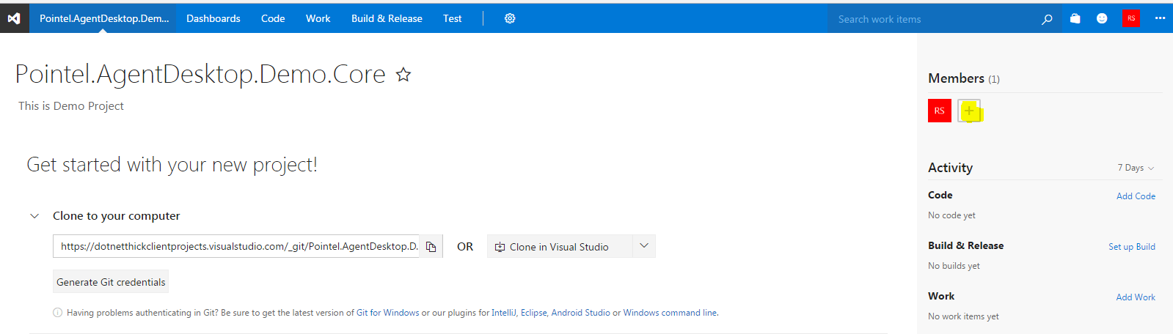

* Click “+ Add” button (highlighted in the screen shot below)

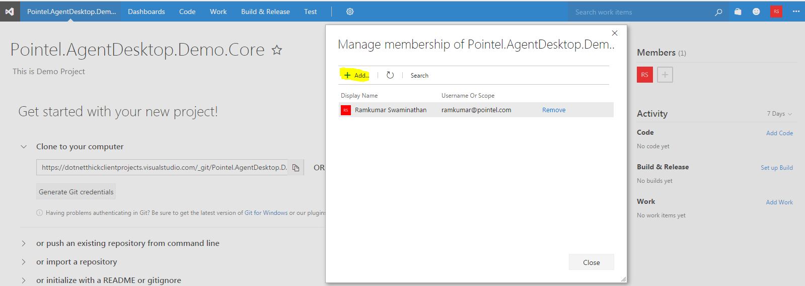

* Search for the team member and click “Save Changes”

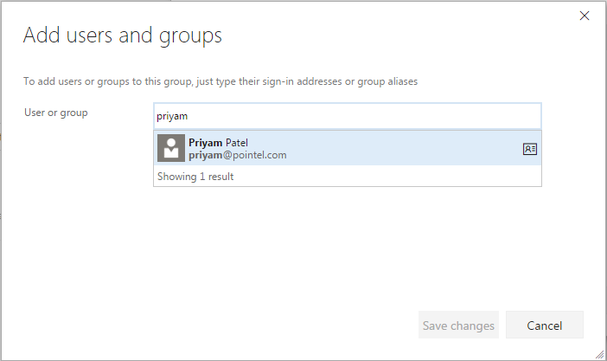

* Click “Close” after adding team members

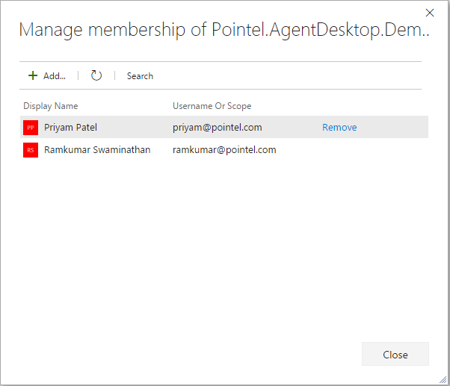

Note: At this point only project folder/repository is created. Either admin or user can create actual project solution and upload it in Team Service project folder/repository

## Administrator Module

### History

Click “Code” from Menu and select History to see the code history

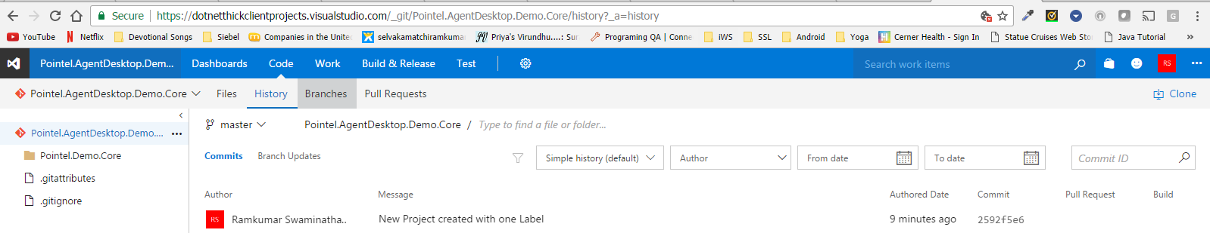

### Code

In the Dashboard, Administrator can see the code uploaded by users. From here administrator can view code, revert changes, download the code and even edit the code.

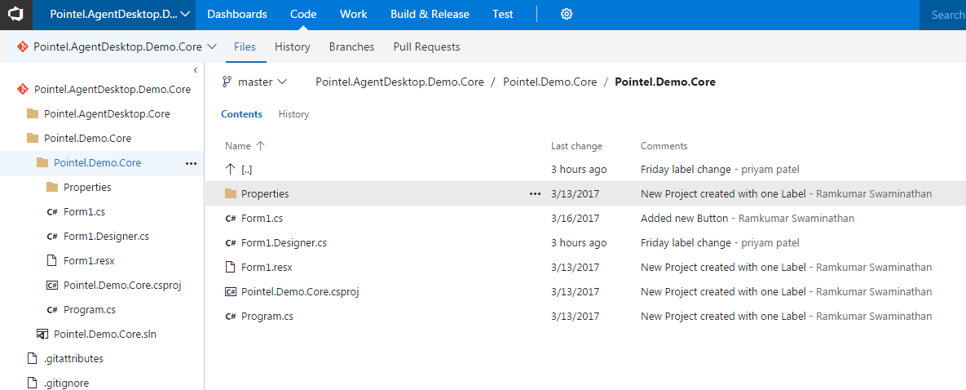

### Assigning Work Item

Using Dashboard administrator can assign task to individuals in the team. Update the task with discussion points, estimation. Below given screen shot shows the task assigned to Team member with estimation.

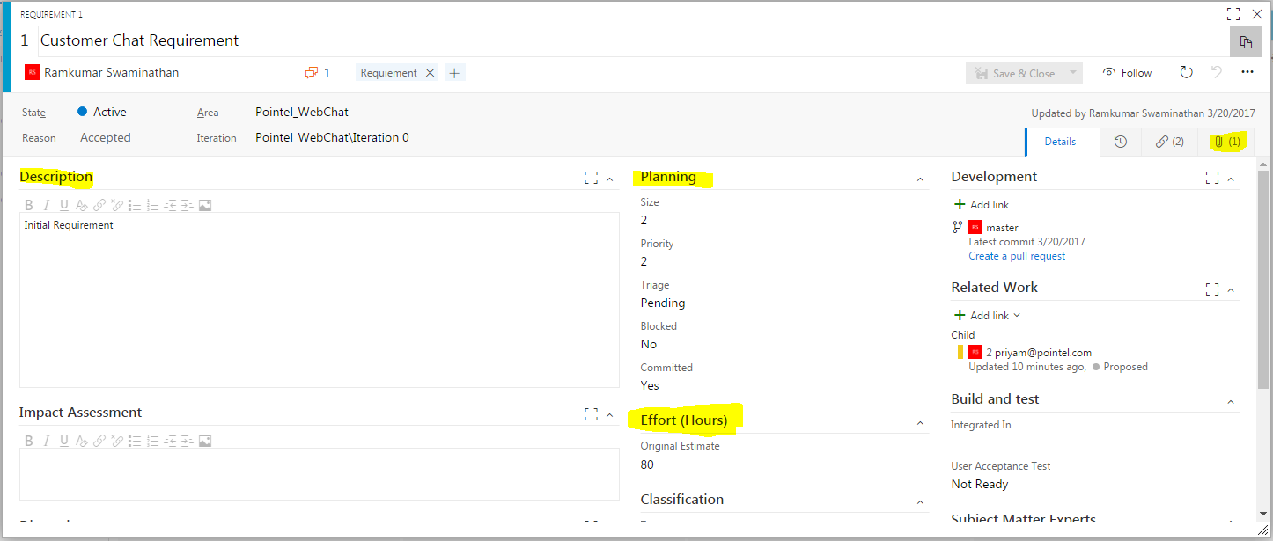

Below screenshot shows how to create and assign new work item to team or team member. Select appropriate work item from the list as given below

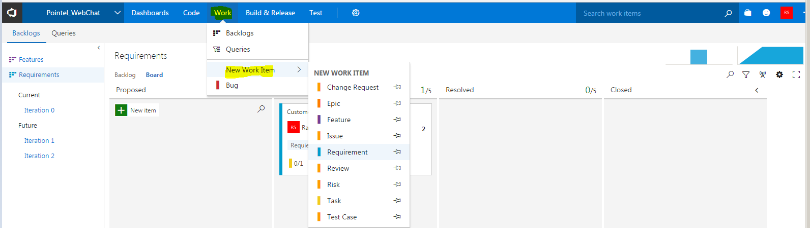

Here I have selected “Requirement” as work item and assigning new requirement to team member.

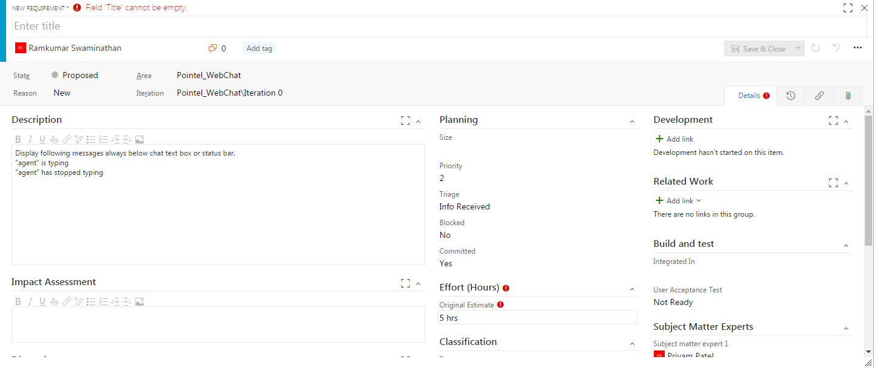

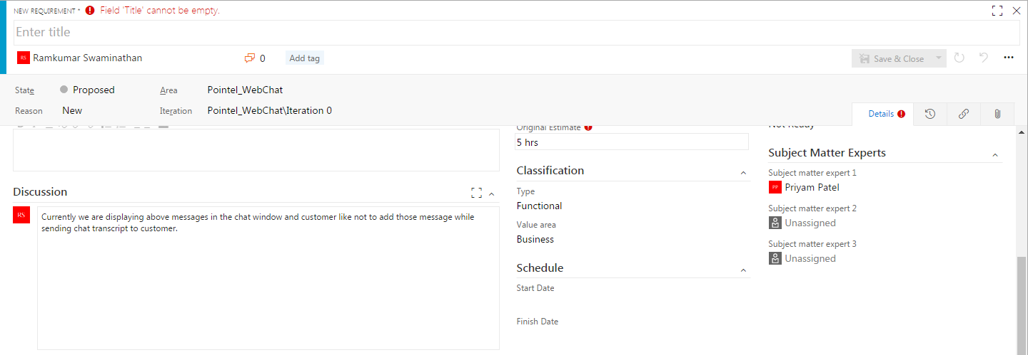

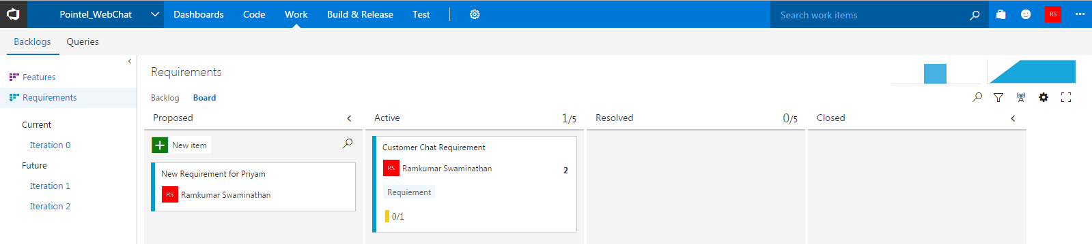

### Notification

Administrator can create notification to get any changes done in project by Team Members. Notification can be created for below activities.

* A commit is pushed
* A pull request is created or updated
* A pull request my team is a reviewer on is updated

Below given details for creating notification.

* Select “Notification” menu from option

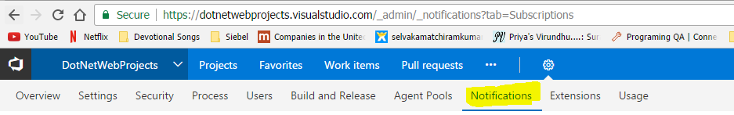

* Click “New” button to create new notification and choose appropriate notification from list

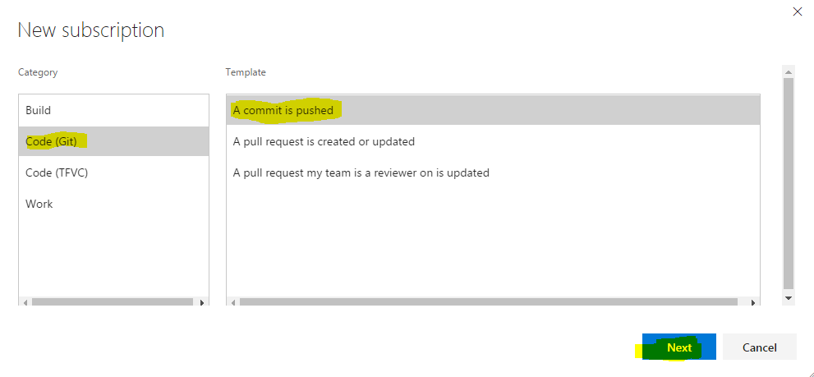

* In Notification screen admin can configure which updates to be notified, who to receive the notification

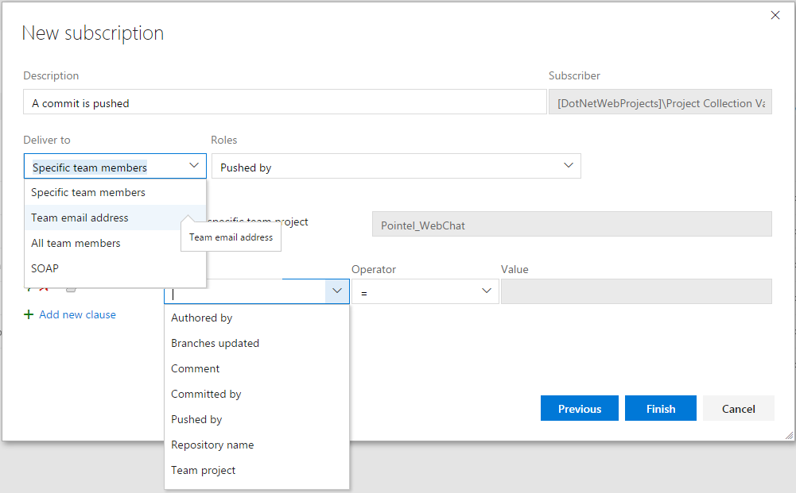

* Sample Notification given below.

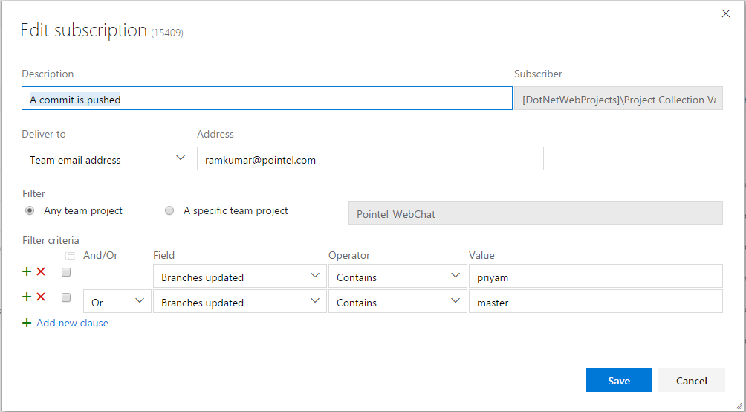

### Benefits of Notification

# User Module

## Connect to Team Foundation Server

* Launch Visual Studio 2015 and click “Team Explorer” from left side view. Click “Manage Connections” menu and select “Connect to Team Project” as given below

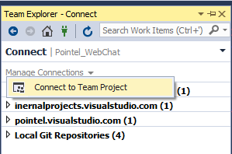

* A Team Foundation Server window popup as given below.

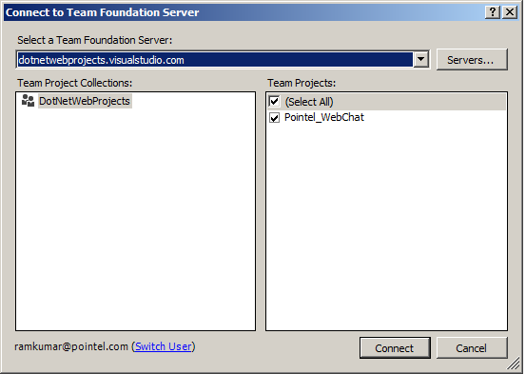

* Click “Servers” from Team Foundation Server, “Add/Remove Team Foundation Server” window will pop up as given below.

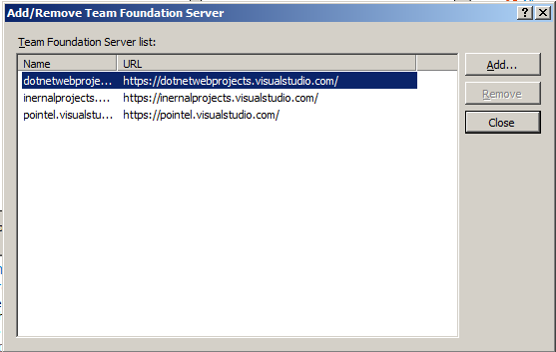

* Click “Add” to enter the new Project URL and click “Ok”, after successful connection “Team Foundation Server” will display project list for the configured account. Select the appropriate project and click “Connect”.

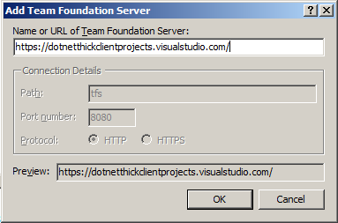

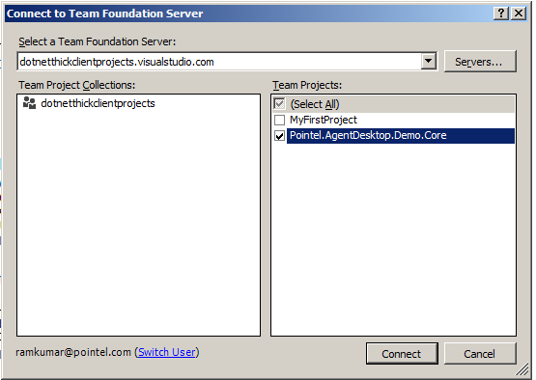

## Clone Repository

* After connected to Team Foundation Server, clone the Team Server repository to local repository. Click “clone repository” from Team Explorer home view

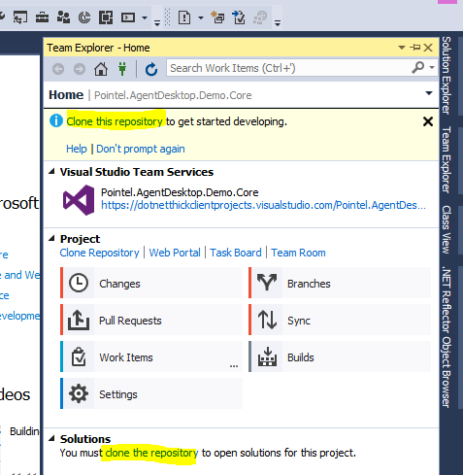

* Enter local path to get clone of Team Service Repository.

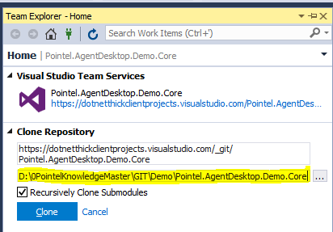

* Now we can create new project solution or open existing project solution.

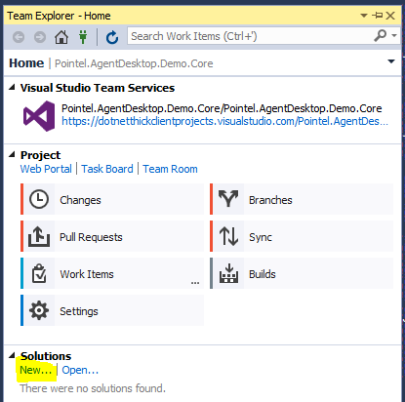

## Create New Project

* Click “New” under solution (refer previous image) and create New project. (This is sample application)

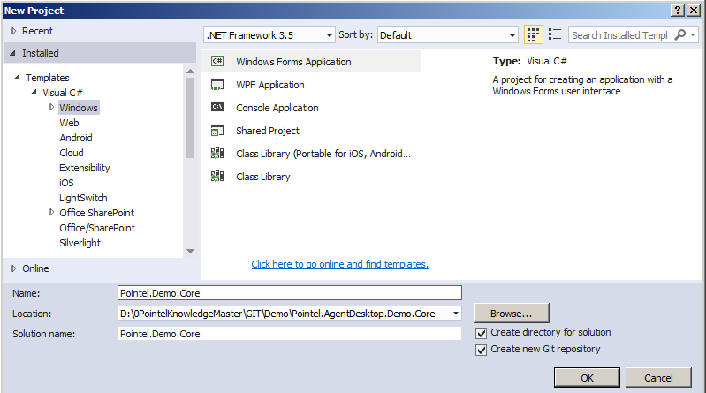

* Solution Explorer will show the list of files created/updated in local repository and required to update in Team Foundation Server

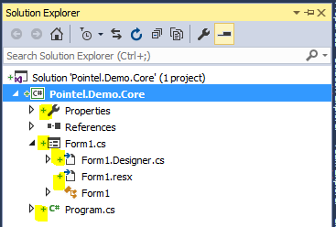

## Open Existing Project

In order to open existing project in Team Services, follow procedure explained in section 2.1 and 2.2 then copy existing solution file (source code) inside the local repository. Team Service will display available solution files from the local repository.

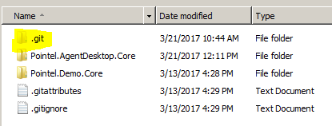

Source code should be copied to “.git” folder location and refresh the Team Service to display the new project in the list.

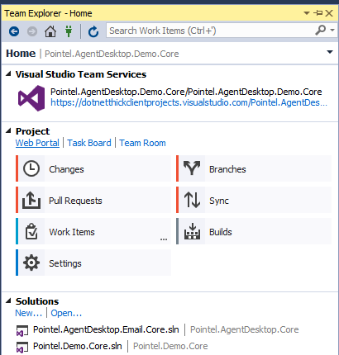

Double click on newly added project to open and follow section 2.5 to commit changes to server repository.

Now 2 project’s added to remote server under same server repository (highlighted is the remote repository)

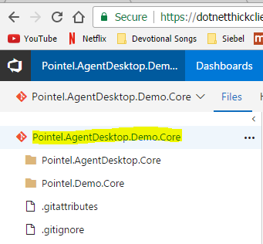

## Commit Changes

* Open “Team Explorer” view and click “Changes”. Changes view will display list of files created/updated in local repository. Enter comments in the text field and click “Commit All” to store all updates to local repository.

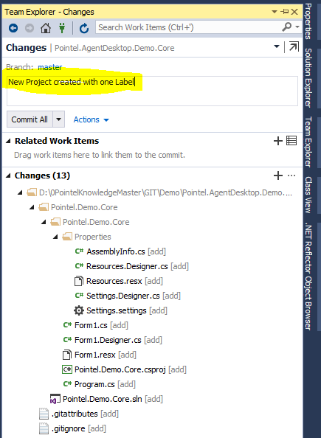

* Now click “sync” to upload all changes to server repository.

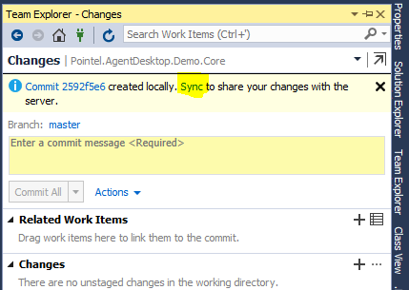

Below screen shows 2 options

Incoming Commits: Shows updates pushed by other users

Outgoing Commits: Shows updates pushed by current user

Click “sync” to completely upload updates to server repository

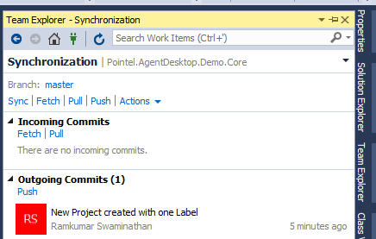

## Create Local Branch

This section helps team members to understand how to develop code or make changes to existing code without affecting master copy in server. First step team member need to create local branch and do all changes to the code and finally while pushing changes to server team member can do any of the following

* Merge local branch with master branch.
* Push the change to server. (New branch will be created in server)
* Open Team Explorer view and click “Branches” and below screen appears

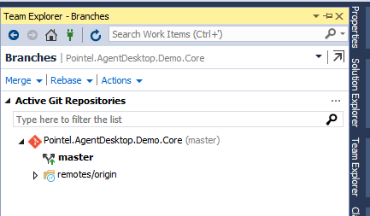

* Click “New Local Branch From” and enter branch name to create new branches.

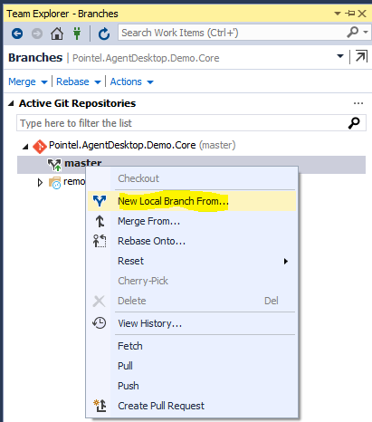

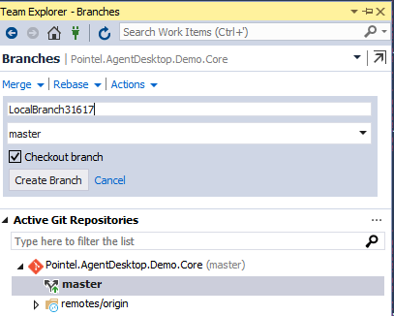

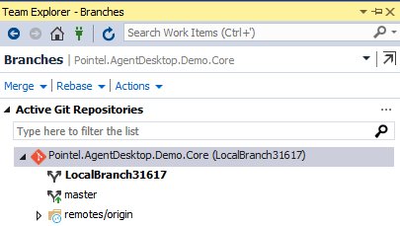

## Merge Local Branch

In order to merge changes from local branch with master branch, double click master branch and right-click to display the option then select “Merge From” option.

Select appropriate branch from list and click “Merge” button

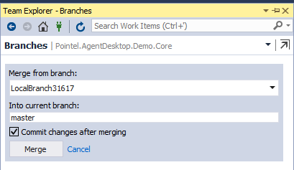

## Pull Changes from Team Members

In order to get updated code from other members in Team, we have to use following step

* Fetch updates from Team Member
* Pull updates from Team Member

Fetch: When team member click “Fetch” as given below, it will show the updated work done by other team members on selected branch.

Here Priyam (Team Member) done some changes in “master” branch

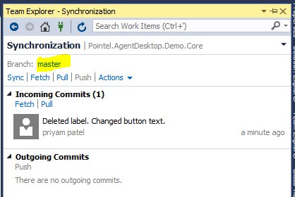

Double click on the message “Deleted label. Changes button text”, it will bring screen as given below where we can do following activities before pulling updates from other team member

* Review the code change
* Revert the code change
* Reset the code change w/o code change

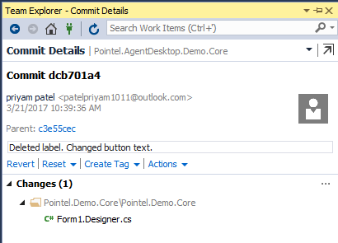

After reviewing the changes click “Pull” from synchronization view.

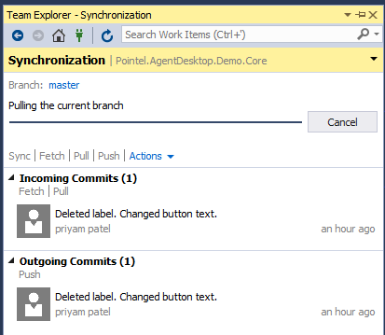

# Miscellaneous

## Updating Same file

Here it shows the conflicts between users update same file and push the update to remote repository. Below screen appears when multiple users try to push the changes to the same file to remote repository.

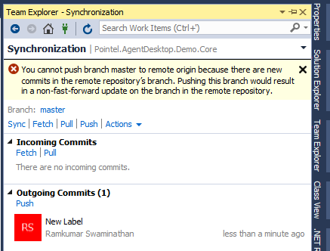

Click on “Fetch” to see the update committed by the user

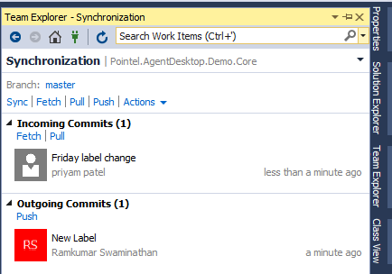

Below screen appear after “Pull” the updates from remote repository

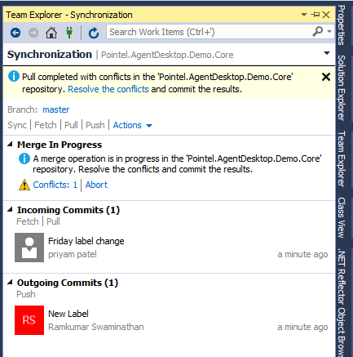

Then user see the difference between local file and remote file and proceed with the changes. Here we taken remote changes to local file and pushed the update together to the remote repository.

